**ICT Breaker Block**

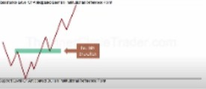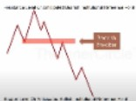Breaker pattern



The short orders will be inside that high, the last upcandle 1 low has to be traded below

So a breaker is a 1 time thing, where as a mitigation block can form constantly

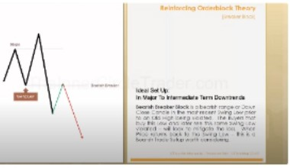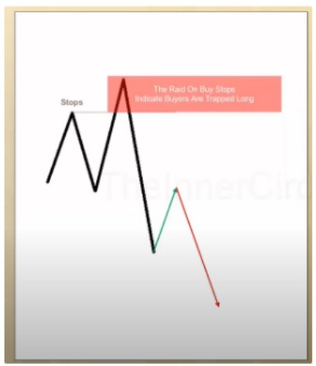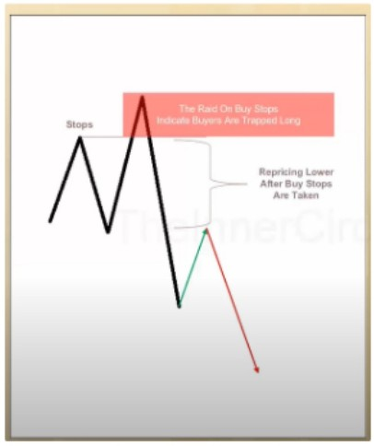

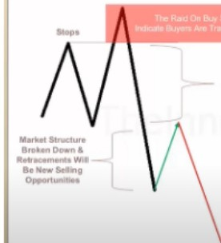

- ­..._

We know the buyers are trapped when price quickly goes down, so a displacement

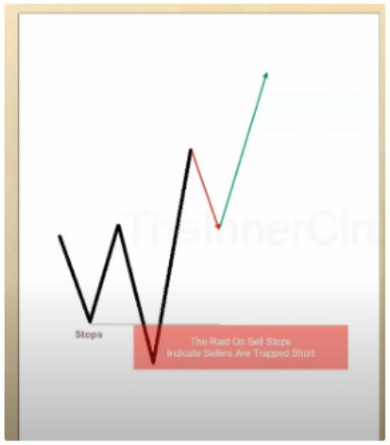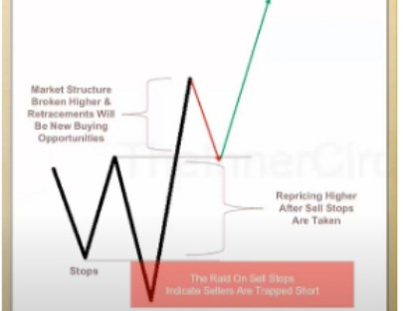I

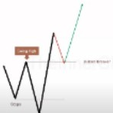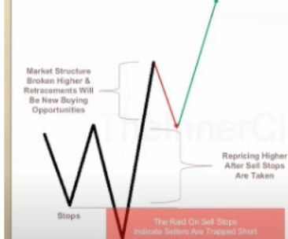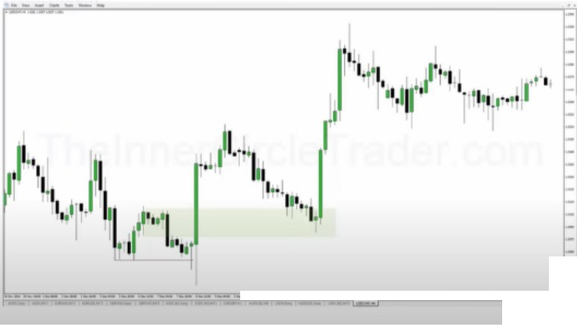

1-

,.,....,,.....,..,...,------...-..,....,,---,, c I

-

-1

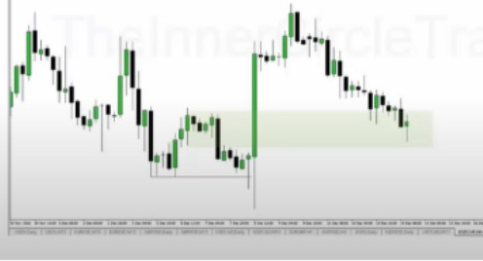

He uses the highest upcandle prior to the downmove and raid on sell stops, and he uses the entire range

ICT also likes to use the bodies of the breaker, instead of the whole candle, thats what i saw in another video

People can get out of their shorts and can add new long positions so thats why the price action is so explosive afterwards

Arjo I Twitter, lnstagram I Linktree

Linktree. Make your link do more.

, https://t.co/HhmmTN1fUI

JavaScript is not available.

*"JI* https://twitter.com/arjoio